Building a Gaming Computer for $900 (Kush and Steven)

<https://www.bestbuy.ca/en-ca/product/asus-21-5-fhd-75hz-1ms-gtg-tn-led-freesync-gaming-monitor-vp228qg-black/12874669> ($119.99)

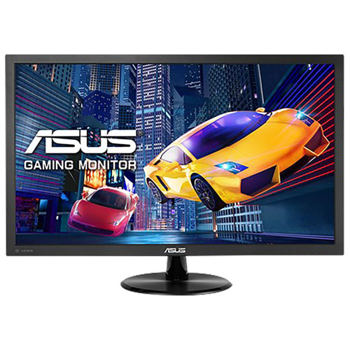This monitor has a 1080p display and has a response time of 1ms – the best you can get and a must have for gaming. The refresh rate is 75Hz, higher than 60hz but not as much as 144hz however our pc will run games on medium to high settings around 70 to 85 fps so it is perfect for our build.

<https://www.canadacomputers.com/product_info.php?cPath=21_273_580&item_id=116153>

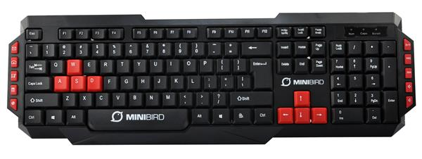We chose this keyboard as it is cheap and is capable of what we need it to do, input to the computer. ($6.90)

<https://www.canadacomputers.com/product_info.php?cPath=21_279_275&item_id=116084>

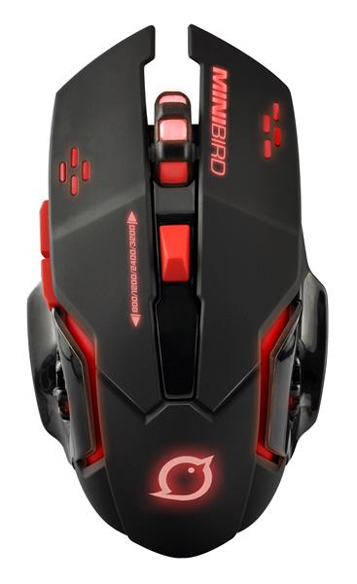We chose this mouse for the same reason we chose the keyboard; it is cheap and allows the user to input to the computer ($8.88)

<https://pcpartpicker.com/list/sbgPmq>

CPU: AMD Ryzen 5 2600 3.4 GHz 6-Core Processor ($129.20 @ OutletPC)

We chose this ryzen cpu is perfect for our build as it has 6 true cores and 12 threads. The base speed is 3.4Ghz and is overclockable out of the box. With this, we can run games and multitask at the same time at very good speeds. This cpu is a better choice as for its price, it offers the most performance compared to similar processors at higher prices.

CPU Cooler be quiet! Pure Rock Slim 35.14 CFM CPU Cooler ($28.58 @ Amazon)

“Be Quit!” has a reputation for making good cpu coolers that are great performance wise and as the name indicates, also very quiet. At this price range most, other coolers would either make too much noise or be a lot less efficient compared to this one.

Motherboard: Gigabyte B450M DS3H Micro ATX AM4 Motherboard ($72.99 @ Amazon)

This Mother board is good for our build as it allows up to 4 sticks of ram to be inserted, making it upgradable in the future. Our CPU as well as CPU fan and gpu all fit perfectly onto this board and the board itself fits nicely into our case.

Memory: Corsair Vengeance LPX 16 GB (2 x 8 GB) DDR4-3200 Memory ($69.99 @ Amazon)

The sticks of ram are dual channel and contain plenty of RAM for our system requirements for gaming. The speed being at 3200Mhz is good for our system and overall for our build as for the same price range other sticks have lower speeds or greater prices.

Storage: Seagate Barracuda Computer 2 TB 3.5" 7200RPM Internal Hard Drive ($54.89 @ OutletPC)

The storage is straight forward: we need space, this drive has 2 TB of it and at a high speed (7200RPM). Others for this price range would be either low on speed or storage.

Video Card: Zotac GeForce GTX 1060 6GB 6 GB Video Card ($213.98 @ Newegg)

The video card was a tough fit but we managed to get it into our build, the 1060 normally has 3gb of VRAM but has a higher clock speed than the 1050ti but we managed to fit in a 6gb model, allowing more intensive graphic games to be ran at better performance. Cards at this range have overheating problems and/or are not worth the higher price.

Case: Fractal Design Focus G ATX Mid Tower Case ($55.88 @ Amazon)

This case has a side panel to display our beautiful interior and is also large enough to old not only our current system but more storage if the time comes to upgrade to more than 2 TB. Others at this range are too small.

Power Supply: EVGA BR 500 W 80+ Bronze Certified ATX Power Supply ($45.98 @ Newegg)

This power supply is trusted and certified bronze 80+, which is all we need really. Our estimated wattage is 289 and it is always nice to have about twice as much in case of an upgrade or overclocking purposes. This one has 500 so it will be fine. Others at this price range are not certified.